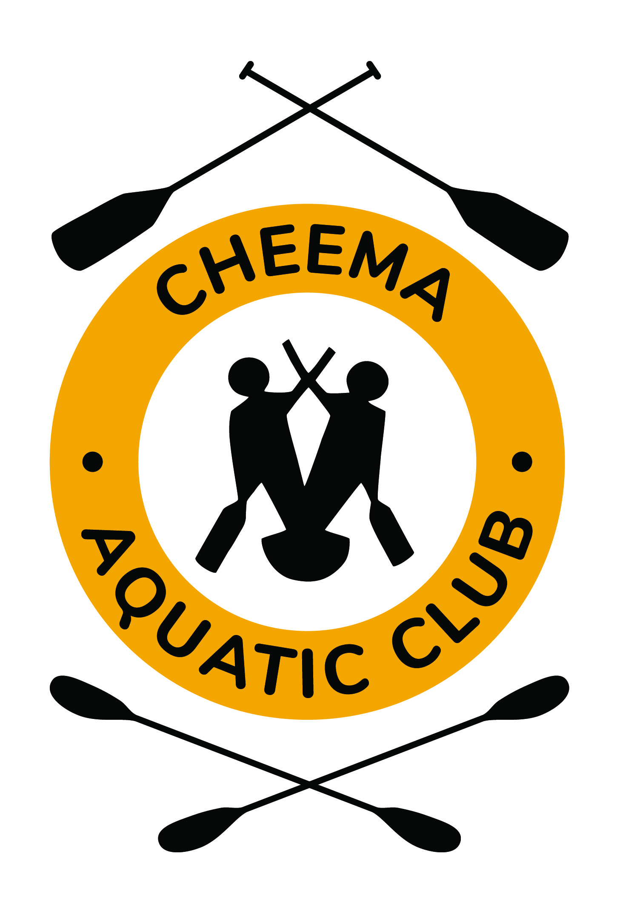
WELCOME TO CHEEMA!

Cheema Aquatic Club 1390 Cobequid Road Waverley, NS B2R 1L9
www.cheema.ca

Thank you for choosing Cheema Aquatic Club for your child's summer recreation. We are already preparing for a fantastic summer that the kids will enjoy! If you are new to Cheema please take some time with your child to view our web site and also review our Anti Bullying policy. Information on hours of operation, what to bring, canteen, etc. will be updated on our website at www.cheema.ca very soon. If you still have questions please contact the registrar Lorelei Audas, at cheemaregistrar@hotmail.com or your summer paddling chair, Scott Smith at scottdsmith@eastlink.ca

For our full summer participants the Regatta schedule for this coming summer can be found on the ADCKC www.adckc.ca website. We encourage everyone to "save the date" for those who are of age to compete. This is a great opportunity for your young athlete to showcase their hard work and share their successes with teammates, family and friends. It is important that all paddlers attend regattas whenever possible as there are only a couple each year. Crew or team boats are dependent on having enough kids at the regattas to race.

Please Like our Cheema Facebook page https://www.facebook.com/pages/Cheema-Aquatic-Club/456792954430445 for updates, events, results and great pictures! All participants will be contacted by their coach approximately one week prior to the start of the program.

CHEEMA AQUATIC CLUB
FIRST DAY!

Beginning at 8am on the first day, coaches and some board members will be available to parents to answer questions.
Volunteers will be on hand to set up canteen accounts, sell racing shirts, answer questions, give tours of the facilities etc.
Cheema also has a full time summer supervisor who will be available throughout the day to assist with any questions you may have.
DROP OFF AND PICK UP

Please keep the outside lane of the parking lot free and clear. Enter the circle to drop off kids and leave or park in the center of the lot if you are staying for a bit. The parking drop off lane runs counter clockwise.
Pick up is the same process. If you are just driving through to pick up your kids, make sure they are ready. If not, kindly park and go round them up. Drive as slowly as you can when entering the Cheema property, some of our paddlers are walkers and may be walking up or down the hill as you arrive.
The kids will be supervised between 8am and 5pm but the program runs from 9am to 4pm. During non-program hours, the kids generally play in the grass or sit in the shade with their friends, the water is out of bounds and unsupervised for both boats and swimming. The kids are watched but this is “free time” which by the way, they enjoy!

WHAT TO WEAR

Appropriate clothing should accompany the member to the club and should be carried in a gym bag along with plastic bags for wet gear. Dry gear for home travel avoids potential hypothermia. Running shoes and water shoes are a good combination as we move from water to land activities throughout the day.
SUNCREEN in the gear bag everyday please!
Gear is not to be left in the club as no lockers exist. Clothing lost or missing is not the responsibility of Cheema so stop by the lost and found each day before leaving to pick up those items that have been left behind. Make sure that all clothing, bags and other important items are labelled in permanent ink.

The club area must be free of litter and garbage by day’s end. WE ASK THAT ALL ELECTRONICS BE LEFT AT HOME, INCLUDING CELL PHONES. CHEEMA IS NOT RESPONSIBLE FOR LOST OR MISSING ELECTRONICS.

PERSONAL FLOTATION DEVICES – SAFETY FIRST

Under 11 paddlers are required to wear an approved life vest (PFD) while on the water. The u11’s are required to provide their own lifejackets as they have to be the correct size and fit.
Under 13 and Under 15 paddlers must wear a life belt or life vest. Life belts will be available for use during the summer program but are the property of Cheema and not to be taken home. If your child already owns a lifebelt please make sure it is labelled clearly with their name and taken home at the end of each day.
We suggest that names be placed clearly and with permanent ink on both sides of personal belts and life vests.
Participants of the 2 week recreational programs will be provided with life jackets.

Note: There are no exceptions to this rule.

GETTING TO KNOW YOU

Please note that the first two days of the program will be spent on proficiency testing and club orientation. Children will be asked to do a swim test to make sure they are able to handle the program and be safe.
They will be able to wear their PFD for the 50-meter test and will be supervised closely. They will be taught how to tip, turn and tow a boat and how to treat the equipment. They will get to know their coaches and crewmates. It is during this first couple of days that you may have questions. Please feel free to contact any board members or your child’s coach. Please direct general questions to our summer paddling chair or the summer Supervisor who will be on site daily.
The summer program is suitable for all kids; however, some kids do not enjoy being physically active all day. There is a lot of noise and activity at the club and except for the odd rain day they are pretty much moving all of the time. There are breaks and time for “chilling” but if your child prefers alone time and quiet pursuits, this program may be a challenge for them. On the other hand, it could be what brings them out of their shell and introduces them to a whole new crop of kids that encourage them and push outside of their comfort zone. In the end, we run a great program but know that for some, it just isn’t the right fit. And that’s ok! Better to try different things and find the right one than never to try anything!
The coaches are available to discuss your child’s activities at the end of the day when they are not watching the whole group or you may email them at any time and they will be able to provide feedback on how your child is doing when you are not there.

The schedule for the day program is set prior to the beginning of the competitive season. The frequency of sessions and the intensity of the activity may vary according to the age class and level of experience of each paddler.

EQUIPMENT

Paddles and boats are provided. Diligent care of equipment is a necessity at CHEEMA due to the high cost of equipment. Cheema invests heavily in new equipment every year and it is absolutely necessary for the boats to be well treated. We want to make sure we have our fleet operational all year to make sure the kids spend as much time in them as possible.

EXPECTATIONS

This brings us to another point! It is important for parents to understand that your child will NOT be in a boat for 8 hours each day. Olympic paddlers cannot paddle for 8 hours a day! Our program is designed to have kids in a variety of boats, with a variety of crews in a variety of ways. They will participate in war canoe, dragon boat, singles and crew boats throughout the week but will also be involved in swimming, triathlons, soccer, volleyball, running and maybe even more importantly, spending time with other kids! This is summer after all and the Olympics are a long way off. The majority of our summer kids belong to Cheema because they want to be active and they want to be with their friends. It is after the summer program that some of our kids decide to take it to the next level and join the fall and winter training programs.
We encourage all parents to read the Long Term Athlete Development Plan that we follow. This can be found on the ADCKC web site at www.adckc.ca.
As many parents know, children can be less than kind, without realizing it. We take this very seriously at Cheema. In any environment, where children are learning to be respectful, some develop at different rates than others. We try to encourage a 100% respect environment rather than a Zero Tolerance environment. True Bullying is much different than misbehaviour or disrespectful treatment of each other and so we approach all situations as an opportunity to learn better behaviour. If there are cases where parents need to be involved, you will be contacted by the summer supervisor and will be fully informed. On the other hand, the summer supervisor needs to be informed if your child is experiencing and disrespect or bullying so that we can address it. Our coaches are trained to identify bullying but more importantly, they are trained to both model and encourage helpful and respectful behaviours.

TAKE A DIP!

Swimming is to occur in approved areas only and under supervision.

CANTEEN

The summer canteen will be run and organized by year round paddlers and their parents. The money generated with this fundraiser will go towards the purchase of new boats. The athletes who work in the canteen will receive a nominal fee.
Canteen Hours and Menu: During the summer program the canteen is open Monday to Friday from 11:30-1:00. A volunteer parent is usually there from 11:00 to 1:00 each day to prep for lunch. A special is served daily. A sample menu will be posted at the club and on the web site.
How to Pay: Paddlers may make purchases from the canteen with cash or parents can set up a tab for their children. For your convenience there will be a volunteer parent at the club on the first day of two week camps, so you can set up a canteen tab. Throughout the summer you can send a cheque with your child to the club, made out to Cheema Canteen. They can bring it to the canteen at lunch time or put it in the locked canteen deposit box located outside the canteen. Please put all cheques in an envelope with the paddler’s name. This amount will be added to their tab. (If you wish you may send a small current school picture that will be stapled to their tab for reference purposes only.)

QUESTIONS

All children should be contacted via email by their coach prior to the beginning of the program. If you have not heard from your child’s coach a few days prior to the start of the program please contact the Registrar.
Please visit the Cheema website at www.cheema.ca with your child to find answers to your questions. If you still have questions please contact any one of our board members or coaching staff.

GO CHEEMA GO!

